**Using MySql with Java.**

**Step 1:**

Download MySql Community Server at https://dev.mysql.com/downloads/mysql/

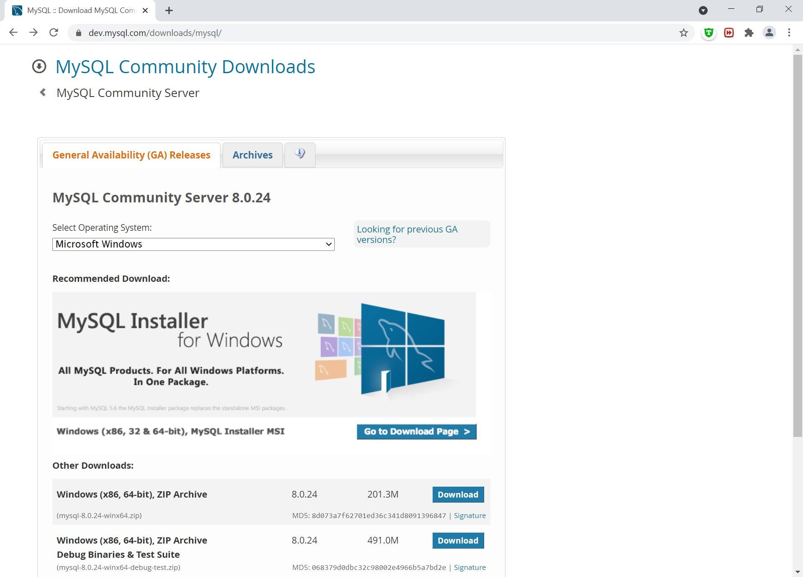

**Step 2:**

Install MySql Community. Leave all choices as is. You can choose any root password as you like.

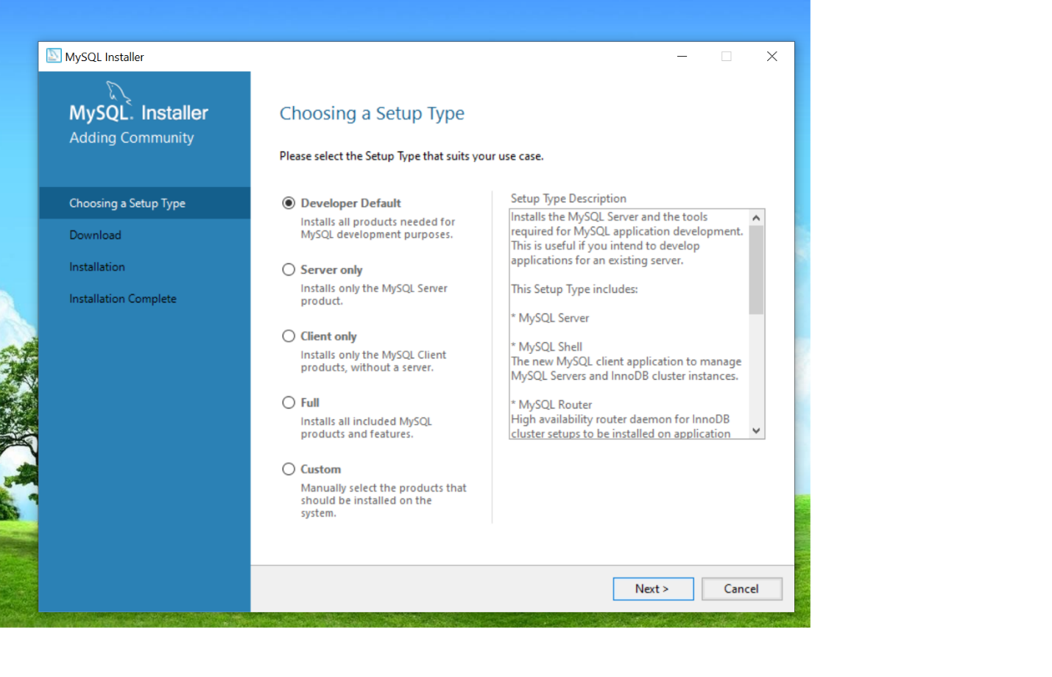

Click Next

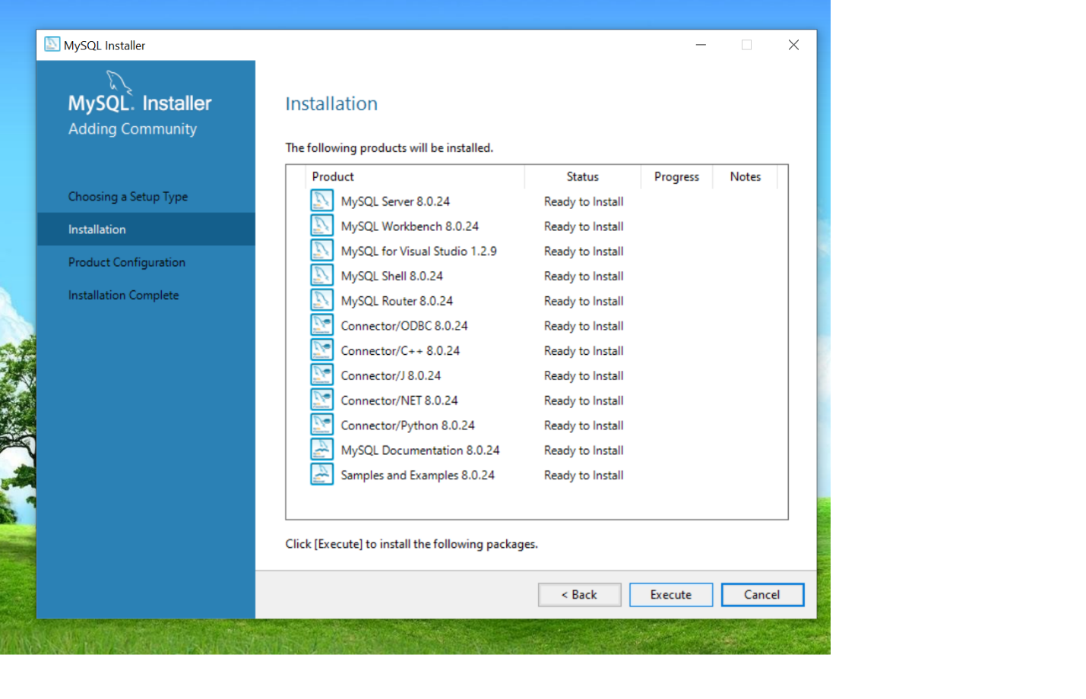

Click Execute.

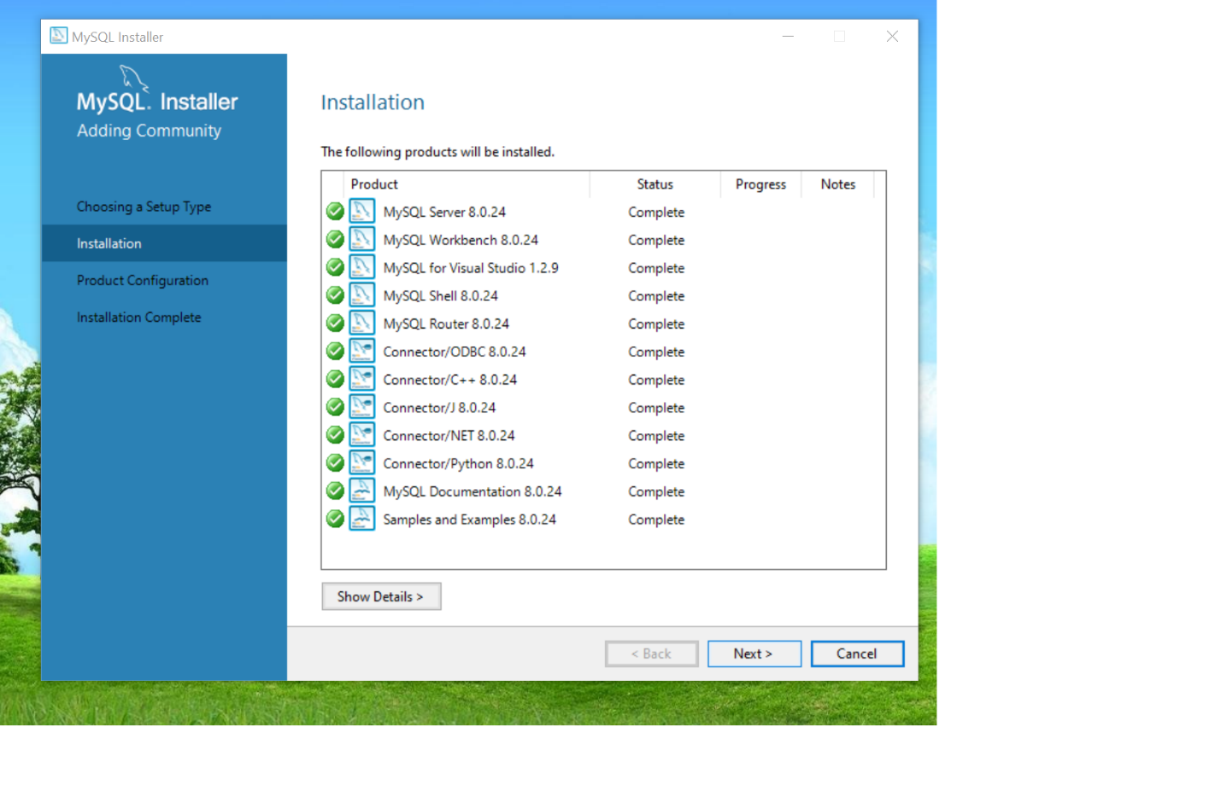

Click Next

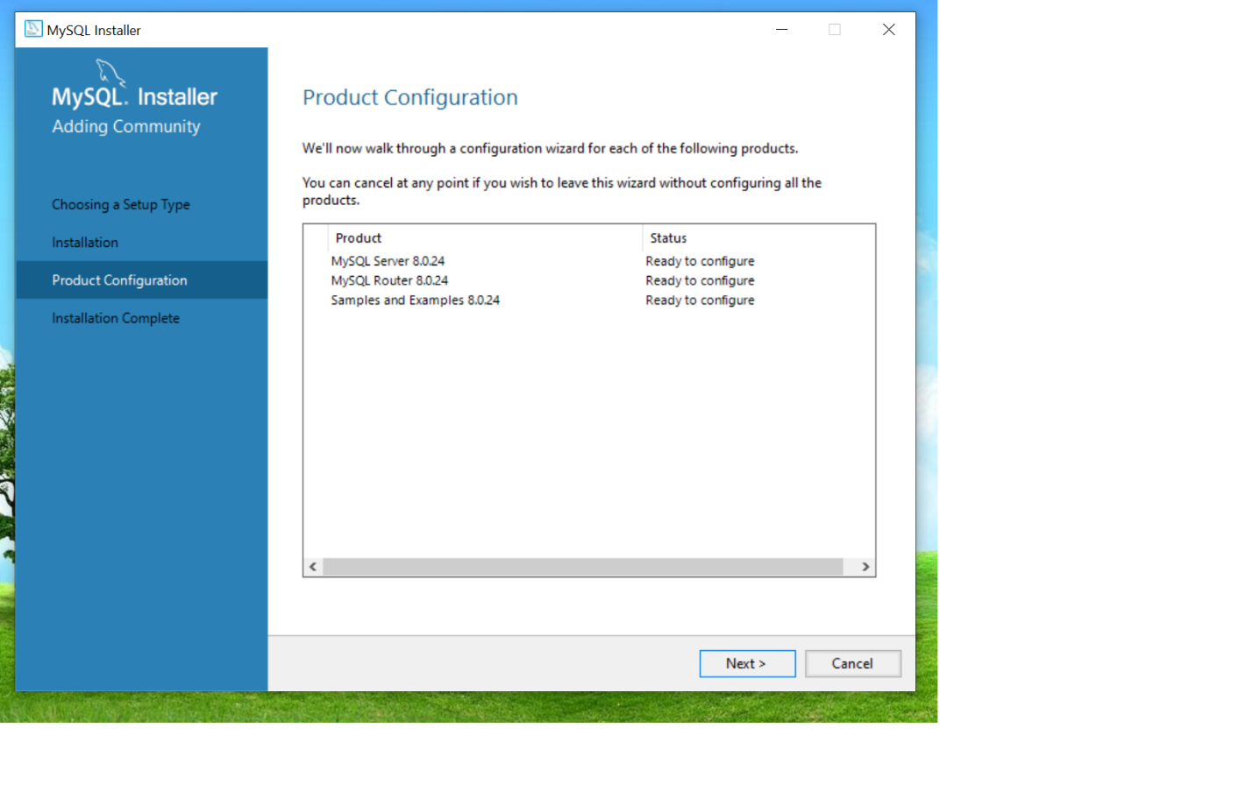

Click Next

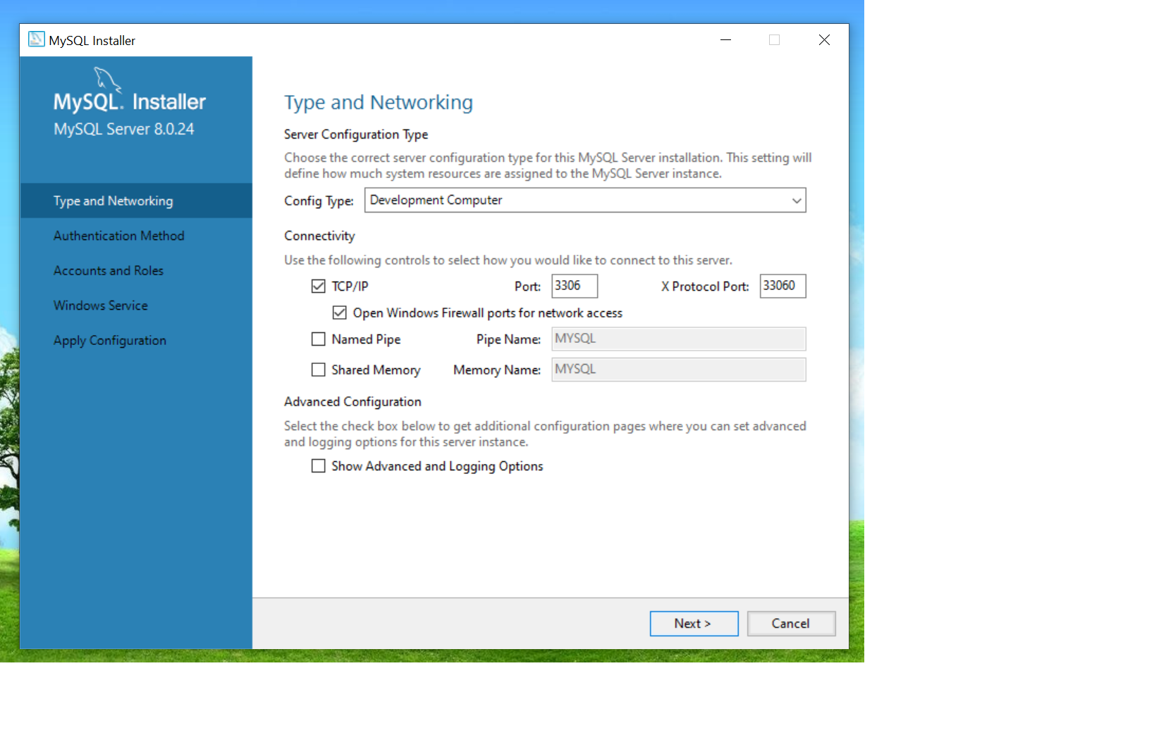

Click Next

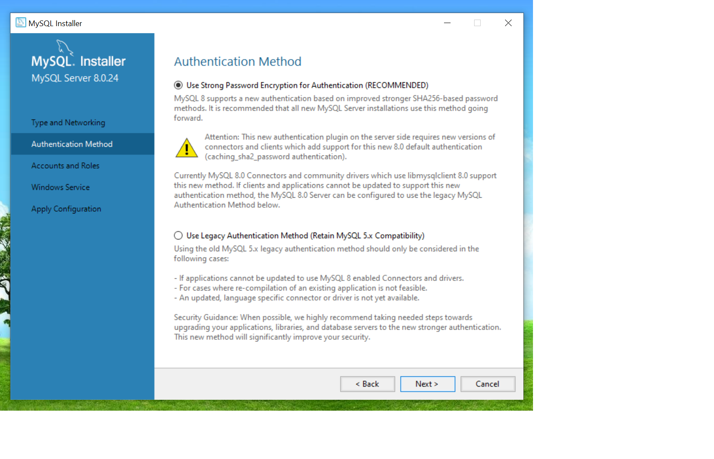

Click Next

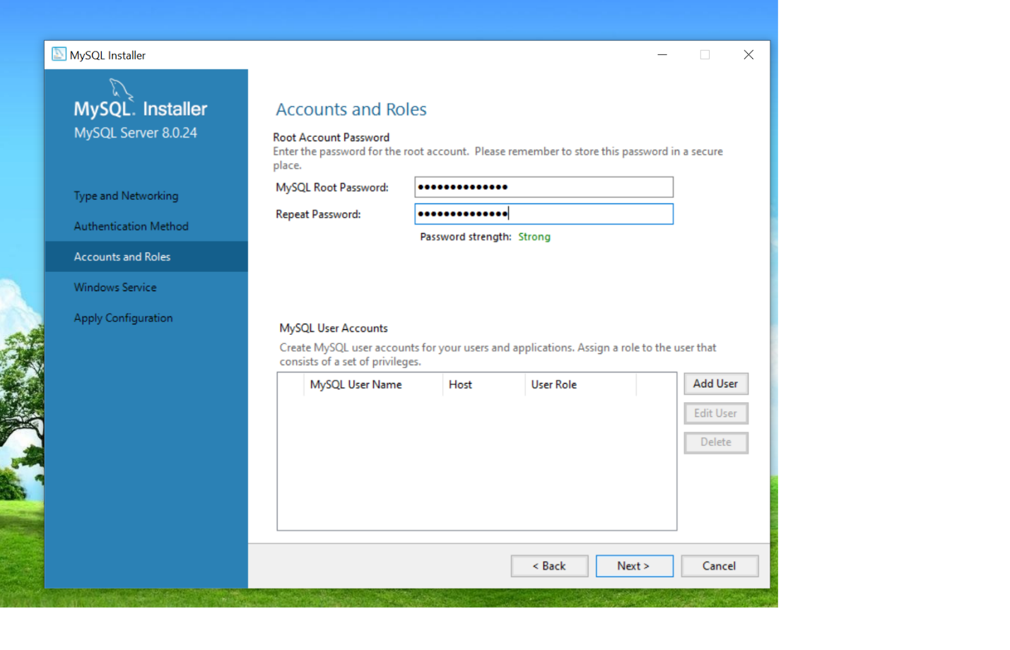

Choose a Root password of your choice and then click Next

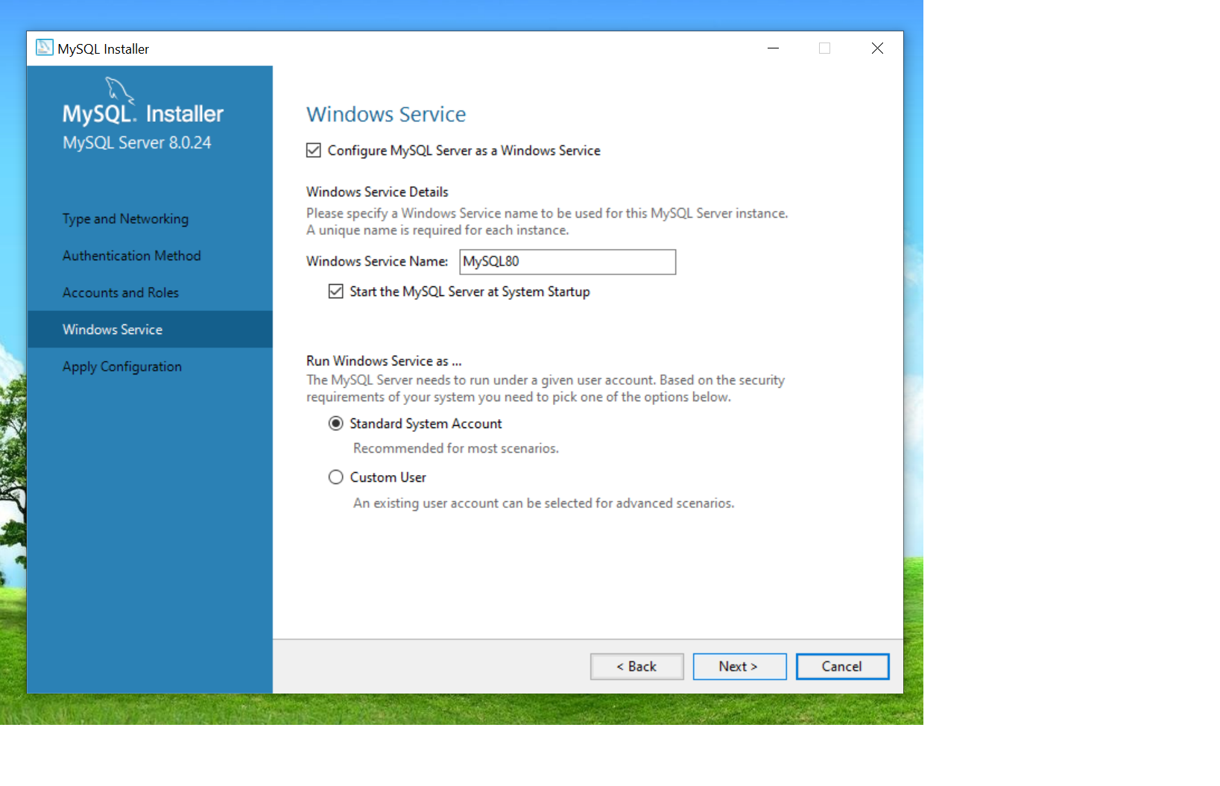

Click Next

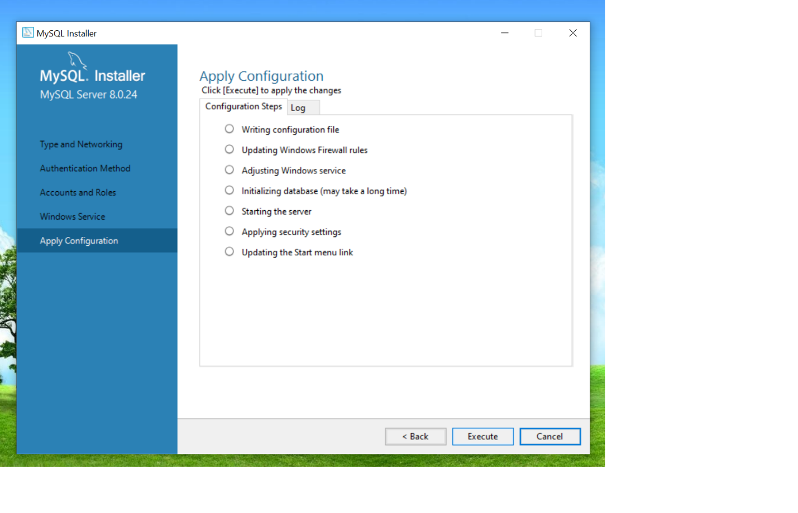

Click Execute

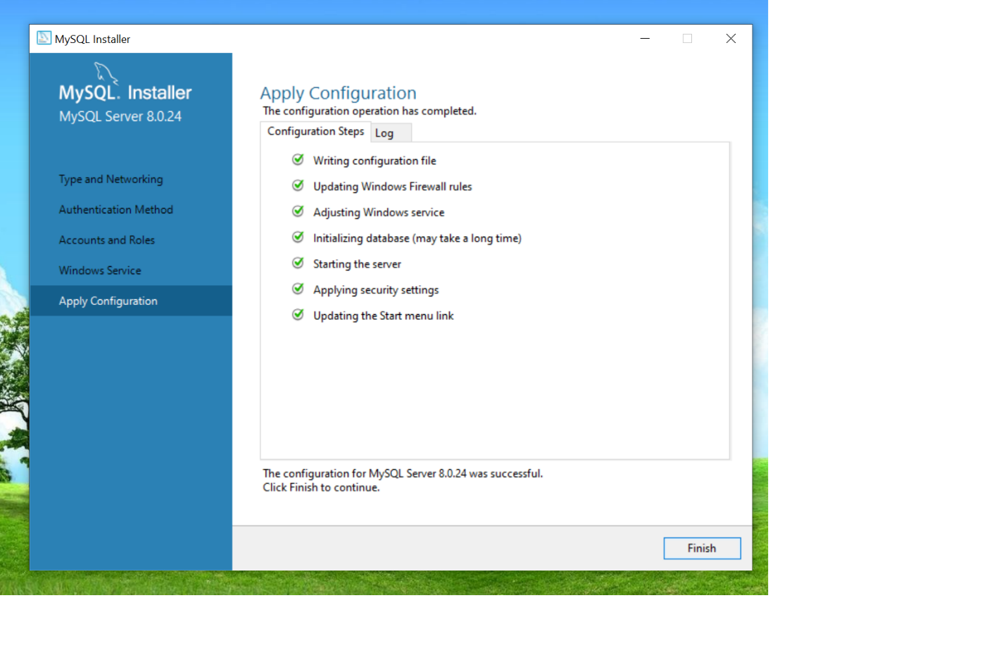

Click Finish

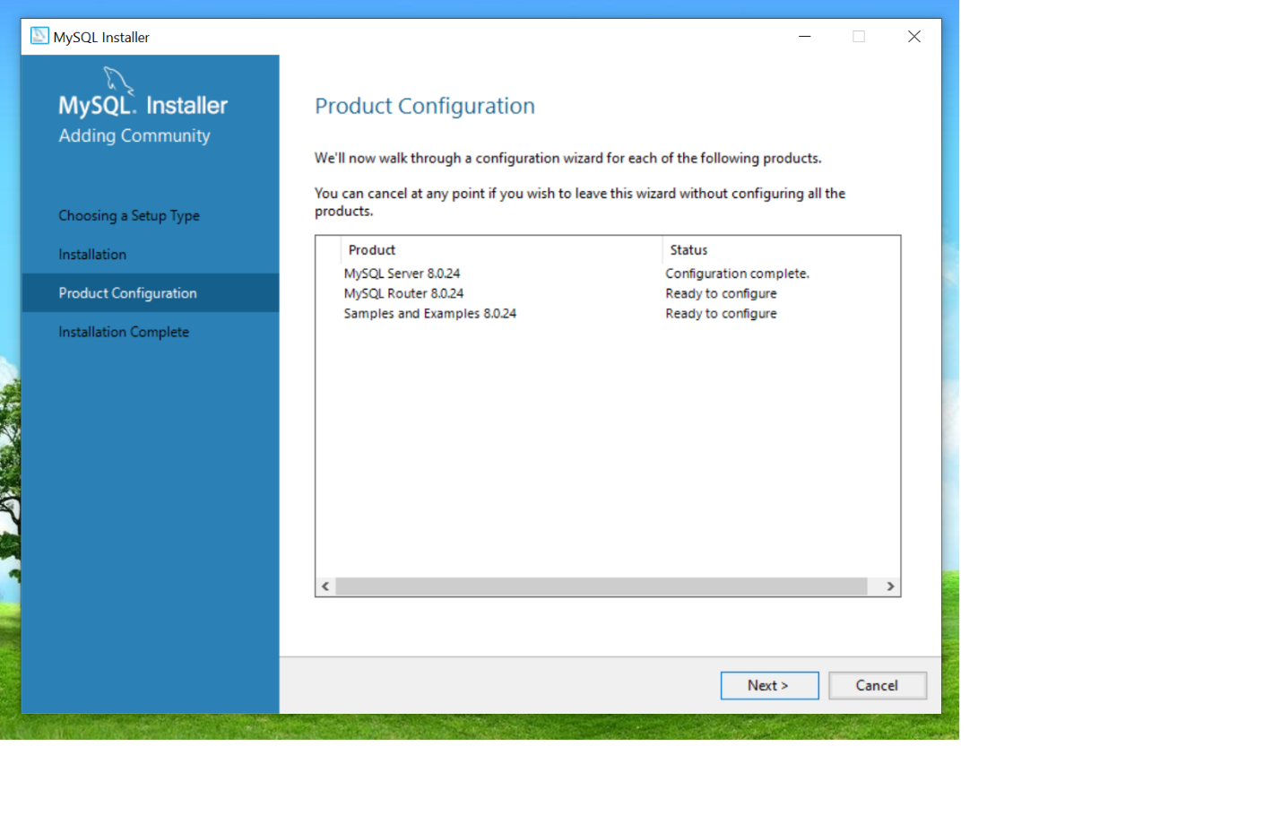

Click Next

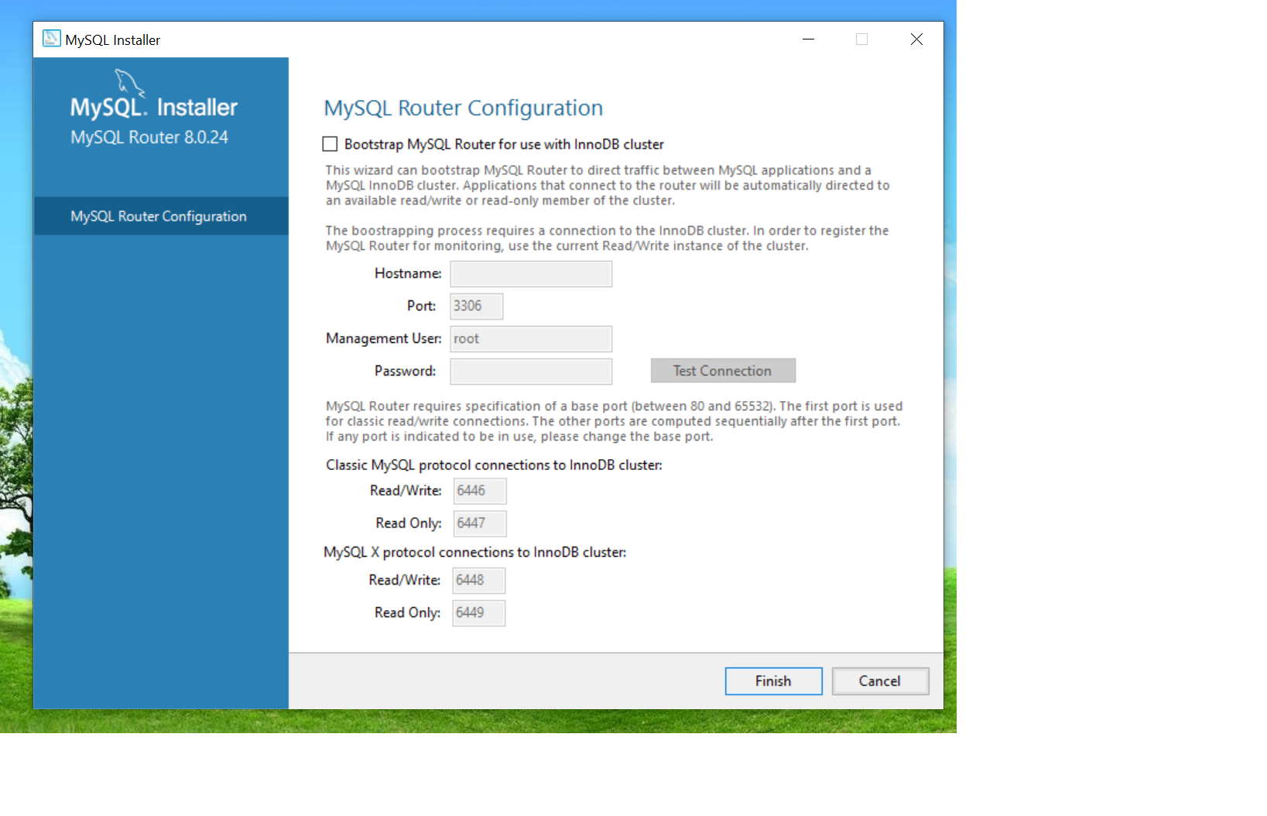

Click Finish

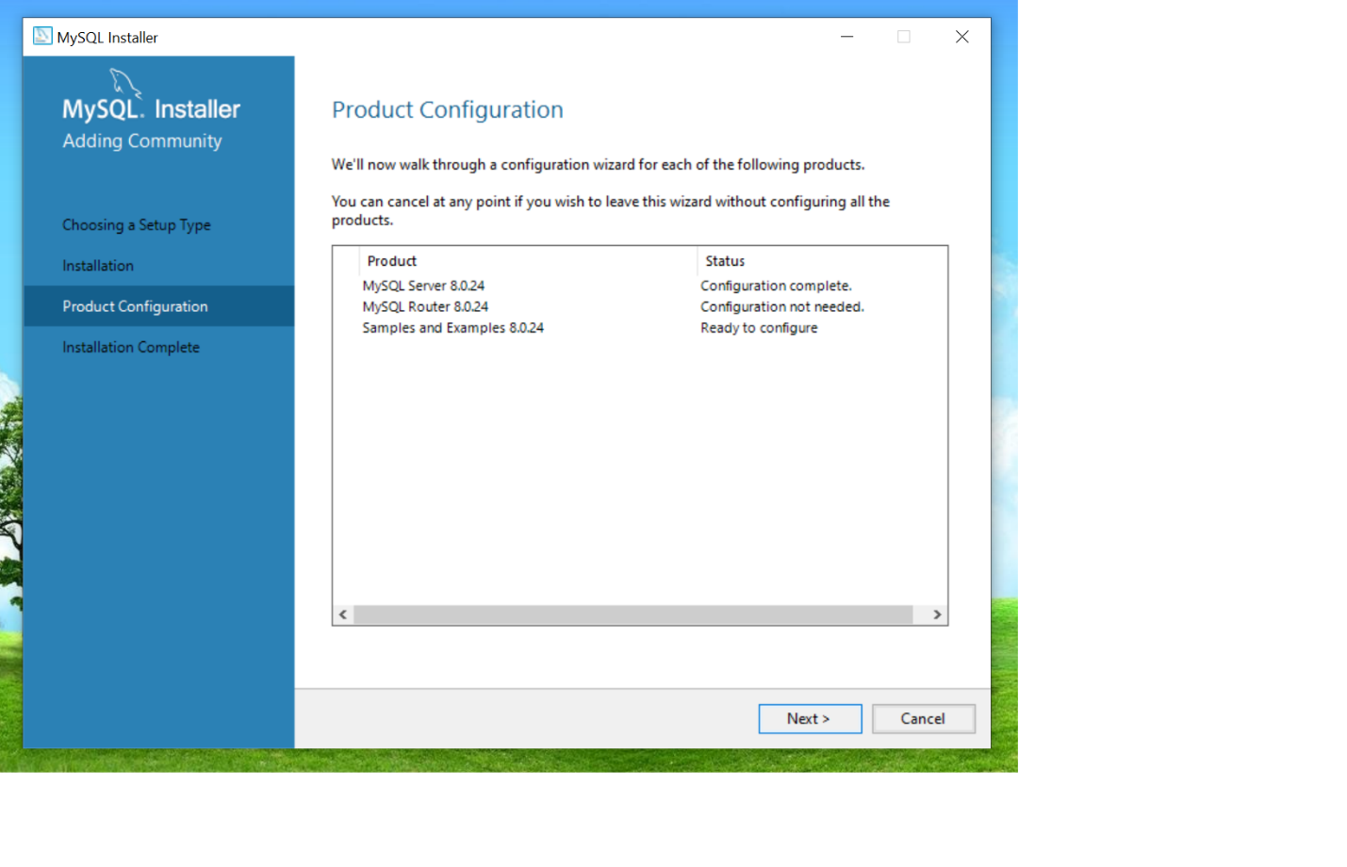

Click Next

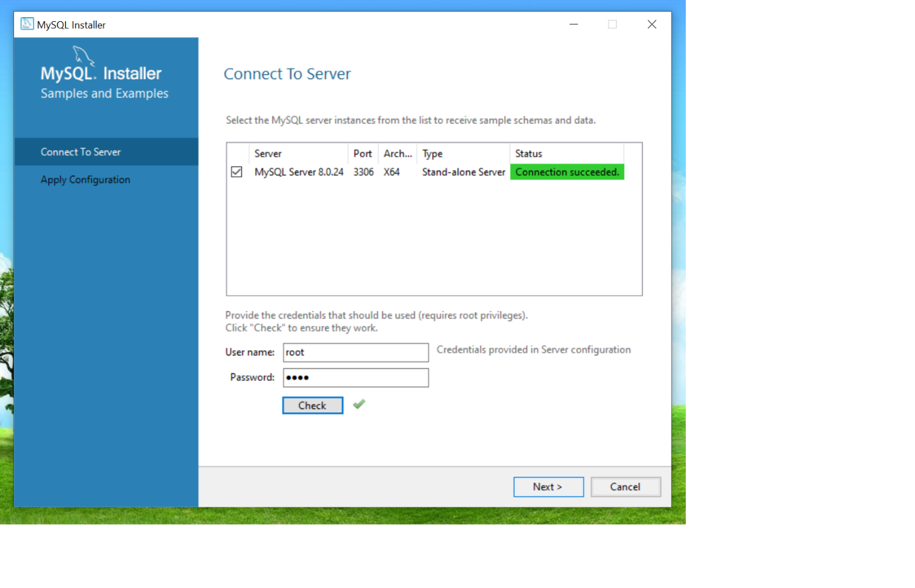

Enter your root password and click Check button to check connection. Then click Next.

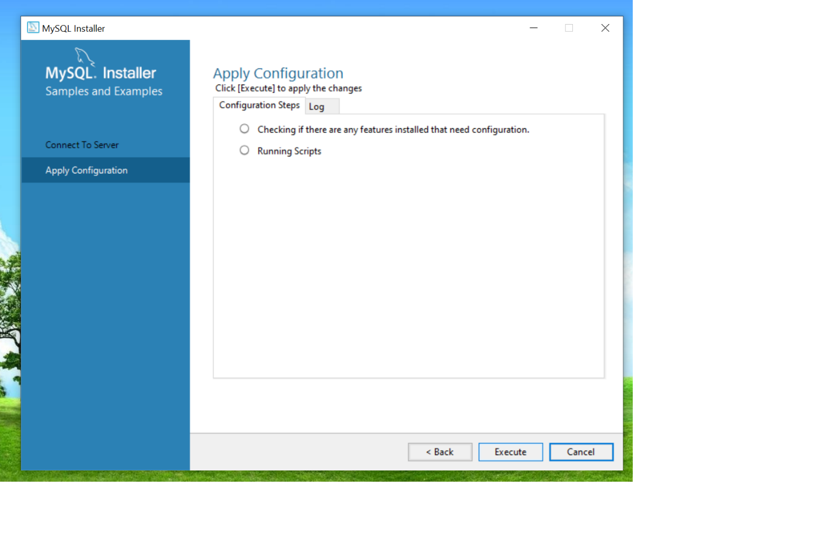

Click Execute

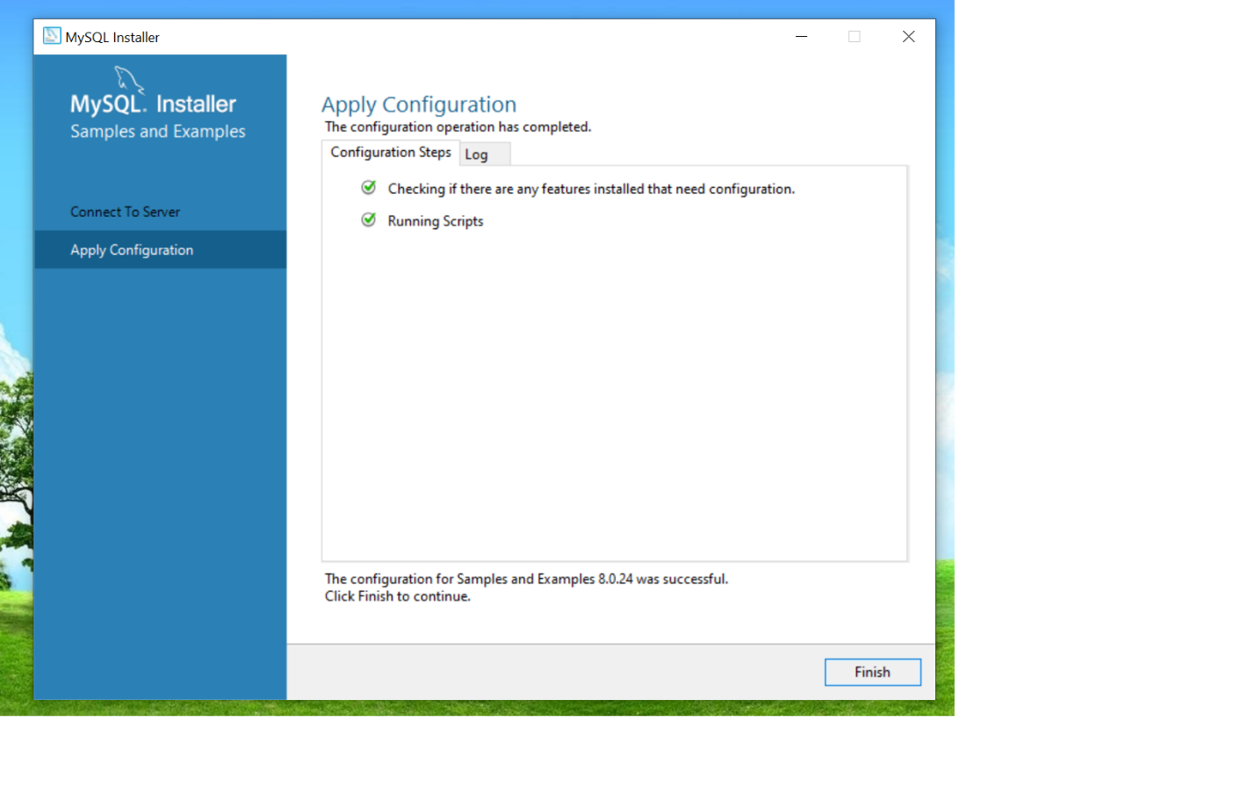

Click Finish

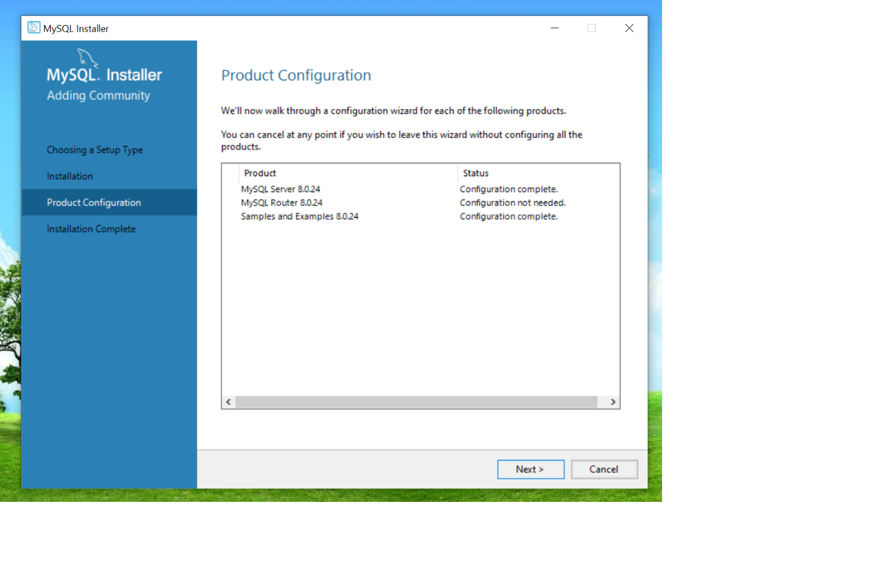

Click Next

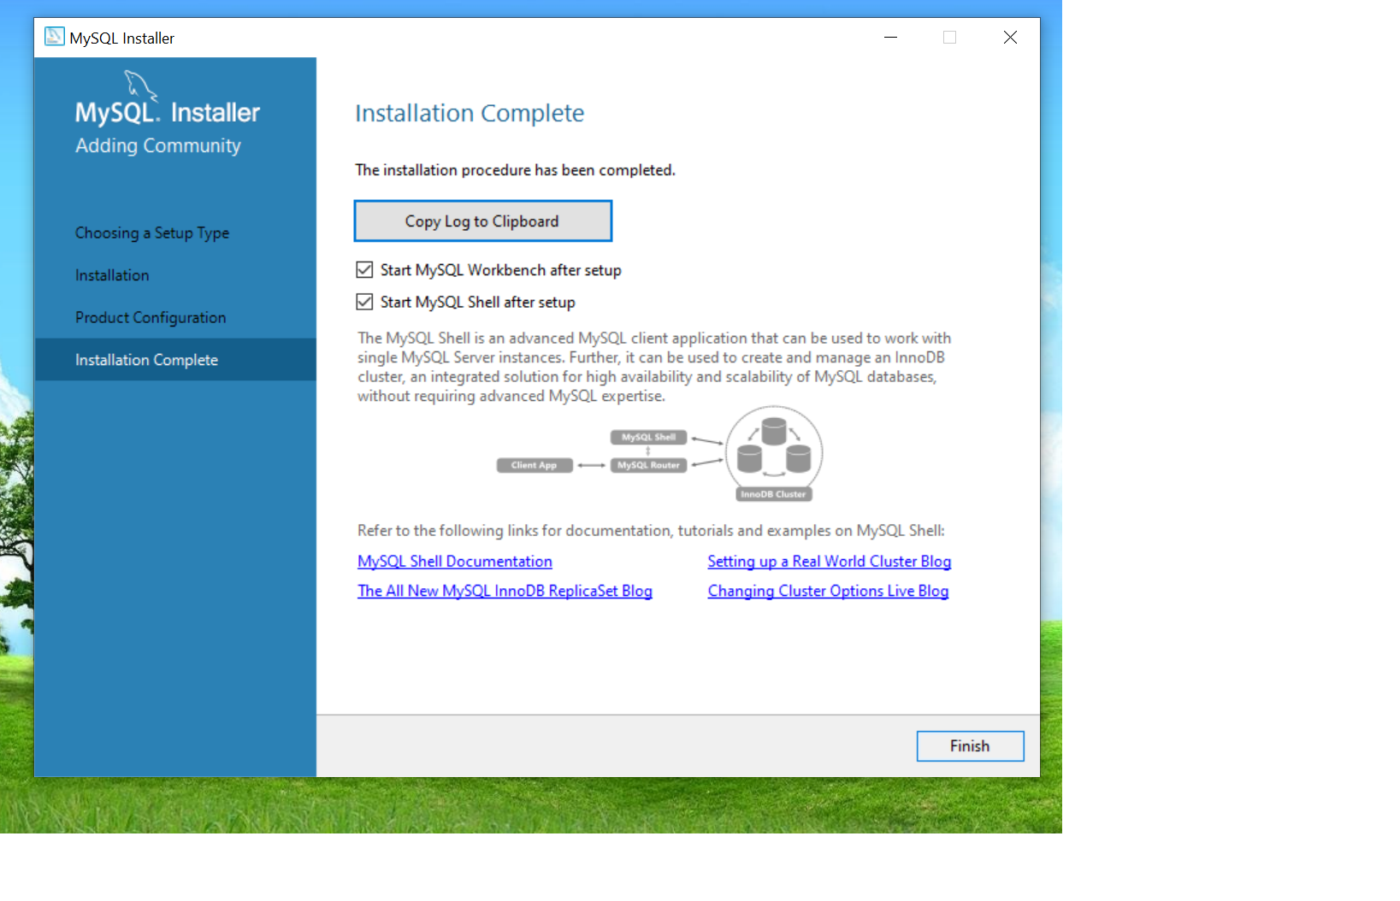

Click Finish

Step 3:

Open MySql terminal and enter you root password.

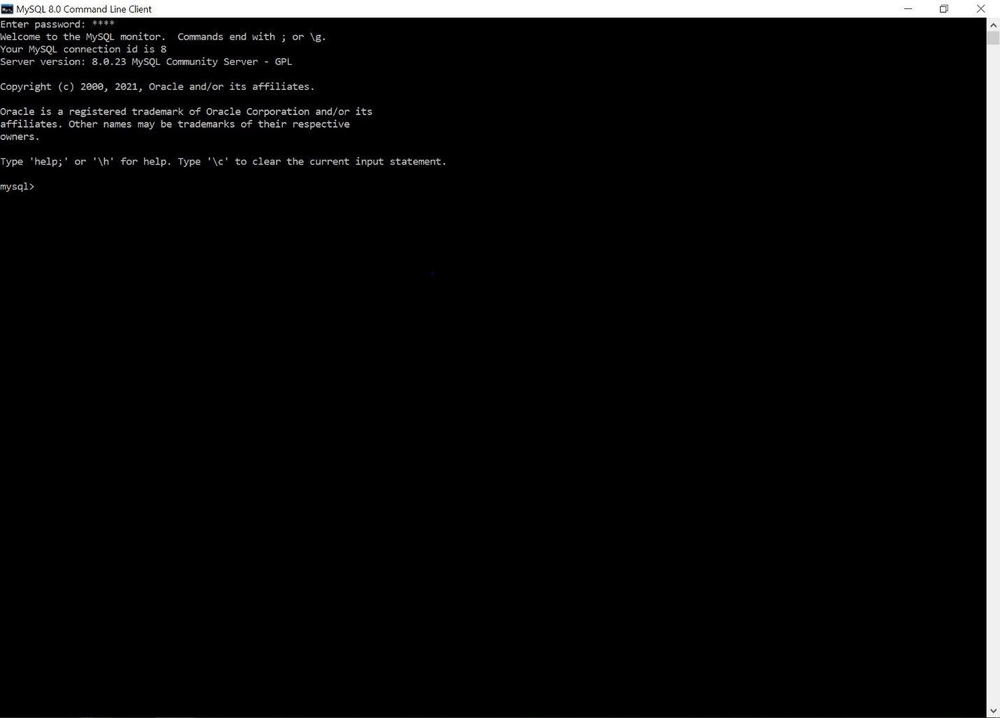

Step 4:

Go to github repo: https:github.com/AOP-Group-1/Project

And copy the exact text within dbscript.txt

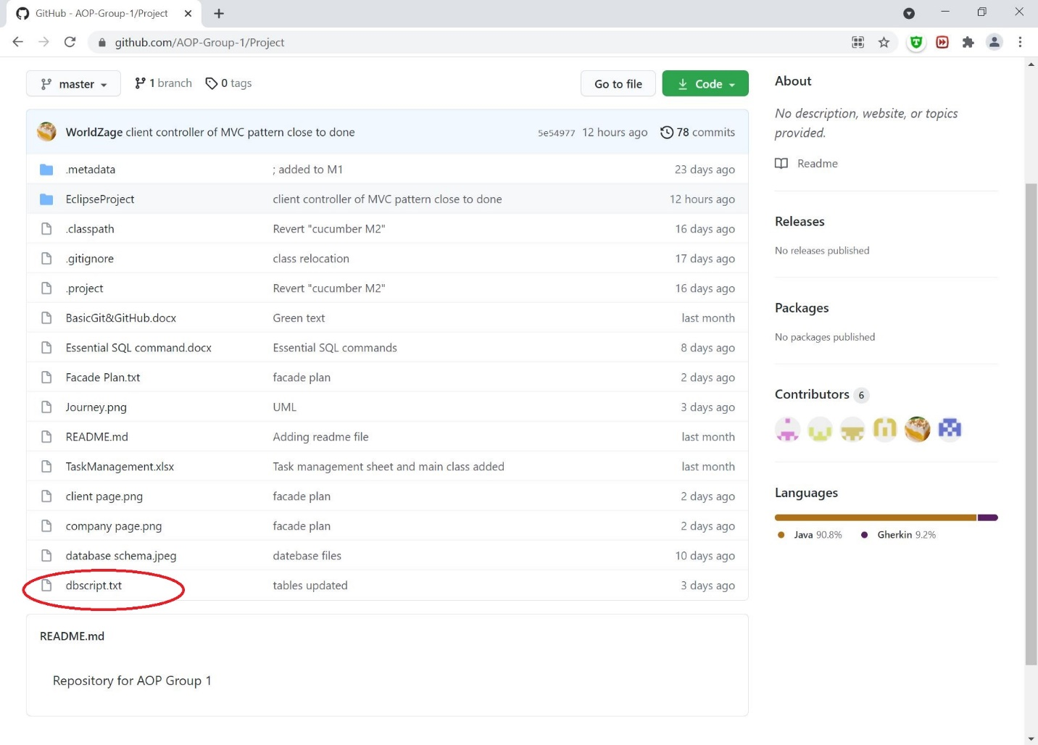

Step 5:

Copy the content in the dbscript.txt file and paste into the terminal.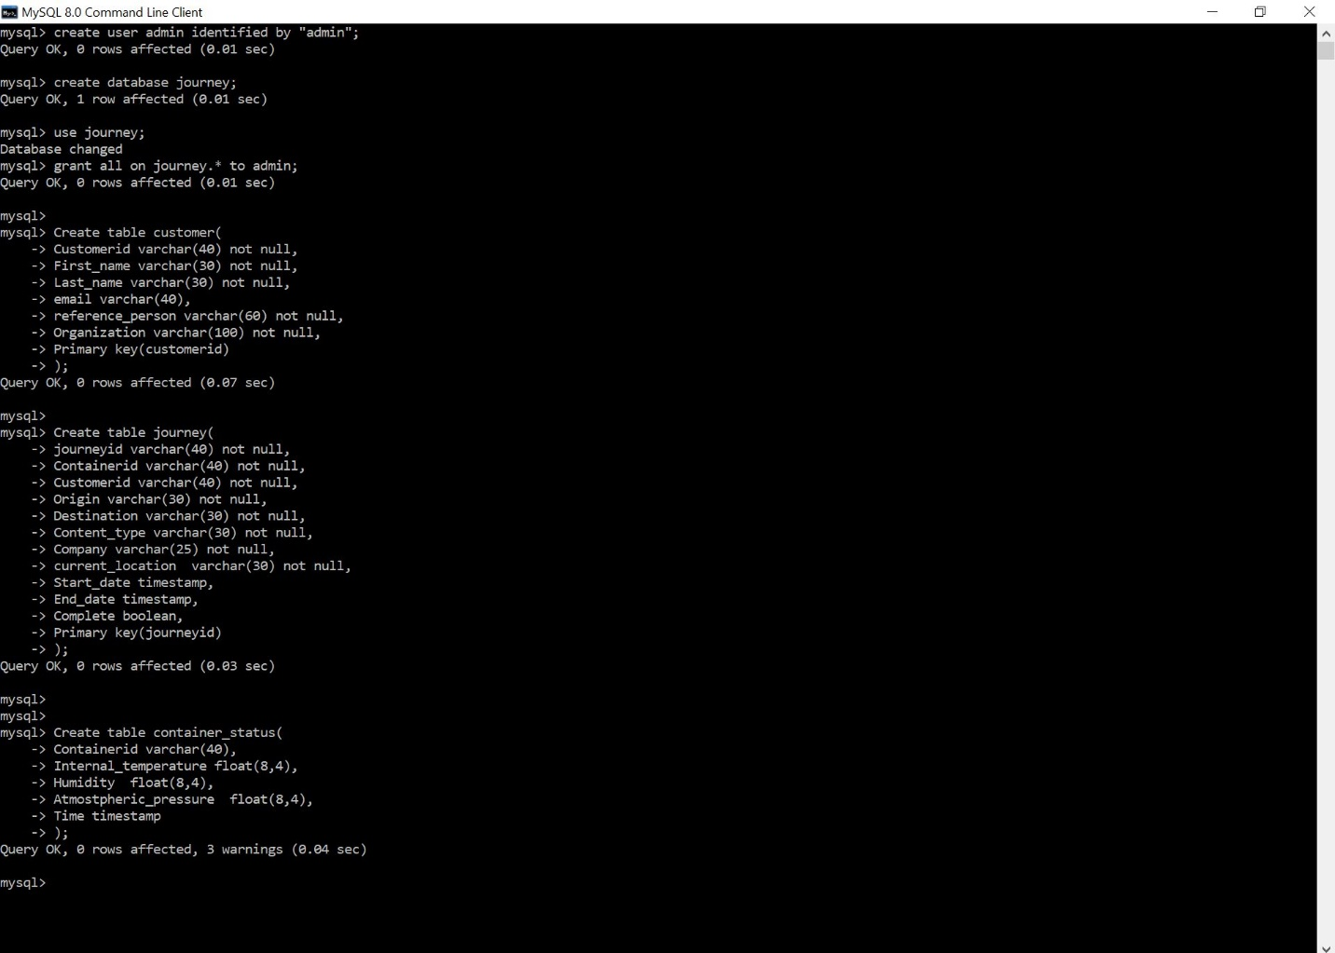

Now the journey database admin account and journey database have been created.

Step 6: Download MySQL Connector at https://dev.mysql.com/downloads/connector/j/

Select Platform Independent from the drop down menu.

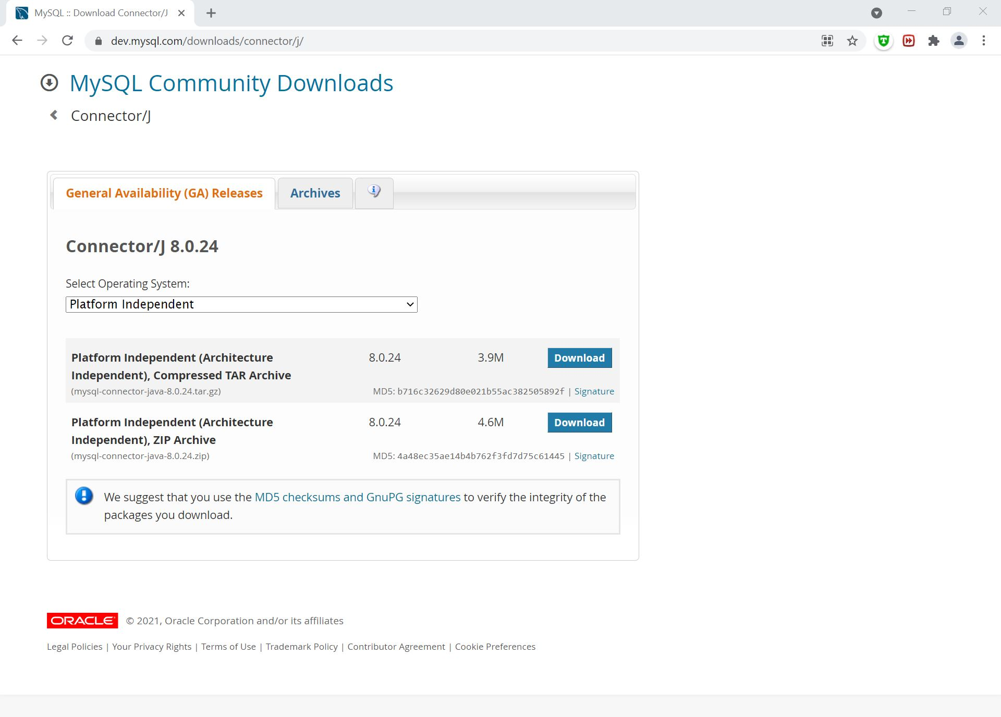

Step 7: Add connector to build path.

Create a new folder called “lib” within the project directory and move the “mysql-connector-java-8.0.24.jar” file into the folder.

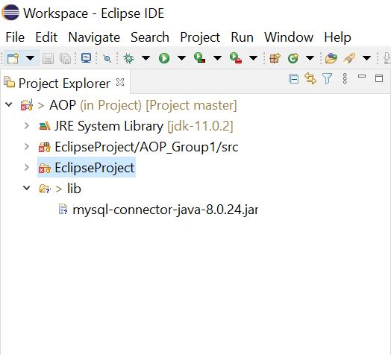

Right click the jar file to add to build path

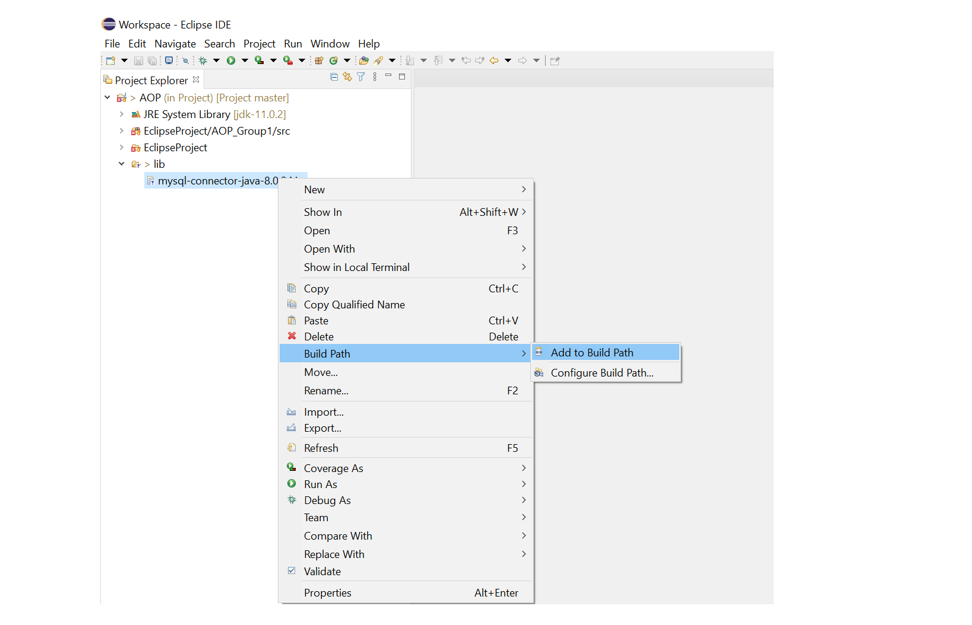

**END**